

**SOUND**

 SOUND

# PROJECT GROUP MEMBERS

|  |  |
| --- | --- |
| **Students ID** | **Students Name** |
| **Student1385888** | **RAFIA NAJAM** |
| **Student1383991** | **MUHAMMAD ZEESHAN** |
| **Student1340103** | **TULAIB KHAN** |
| **Student1363543** | **SYED MUDASSIR SHAH** |

|  |  |
| --- | --- |
| **CURRICULM**  **7062** | **BATCH**  **2206B1** |
| **FACULTY**  **“MS.NEELAM MALIK”** | |
| **CO-ORDINATOR “MS.MUNAZZAH KHAN”** | |

 SOUND

**SCREEN SHOTS**



HOME PAGE

When user open our website, they will see this user-friendly home page.

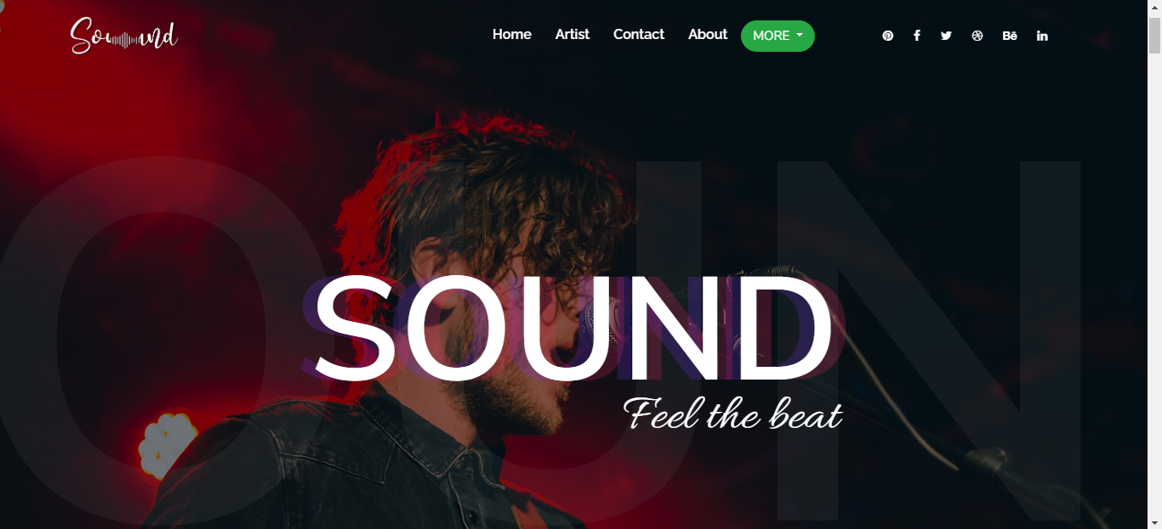



# IN THEATER



# LOGIN

Visitor can Login and register themselves

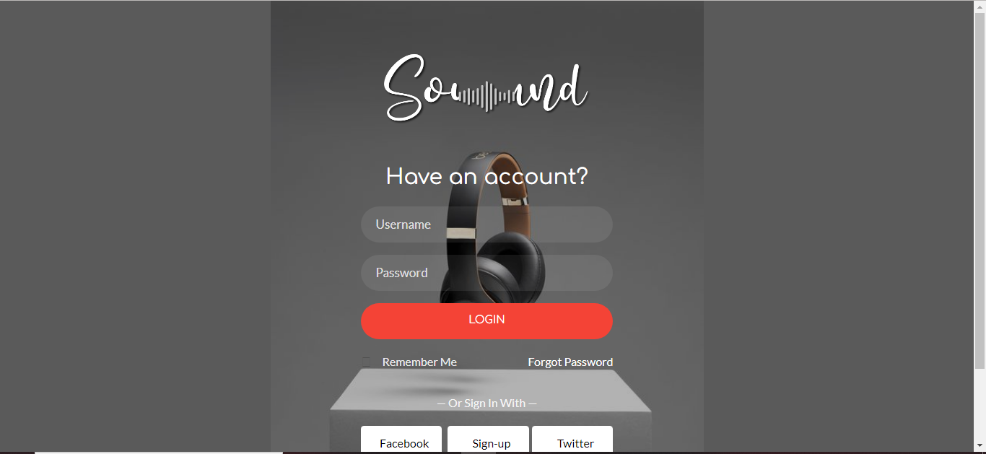

SIGN IN

Visitor can create an account whether they will be visitor, employee or

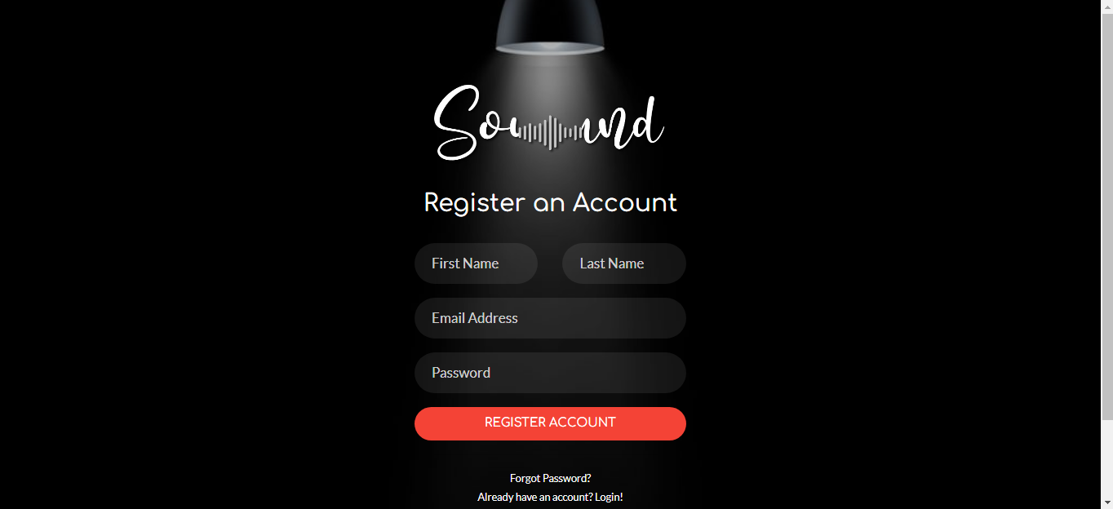



# FOOTER

In the end of the website visitor can see this footer and nav which have some links.

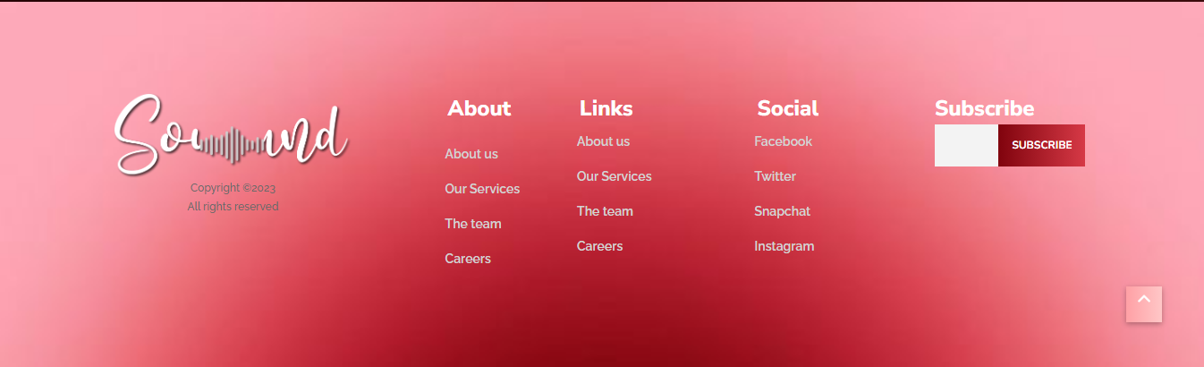

# NAVBAR

# 